JOHN F KENNEDY
MIDDLE SCHOOL
invites you to a fundraising event at

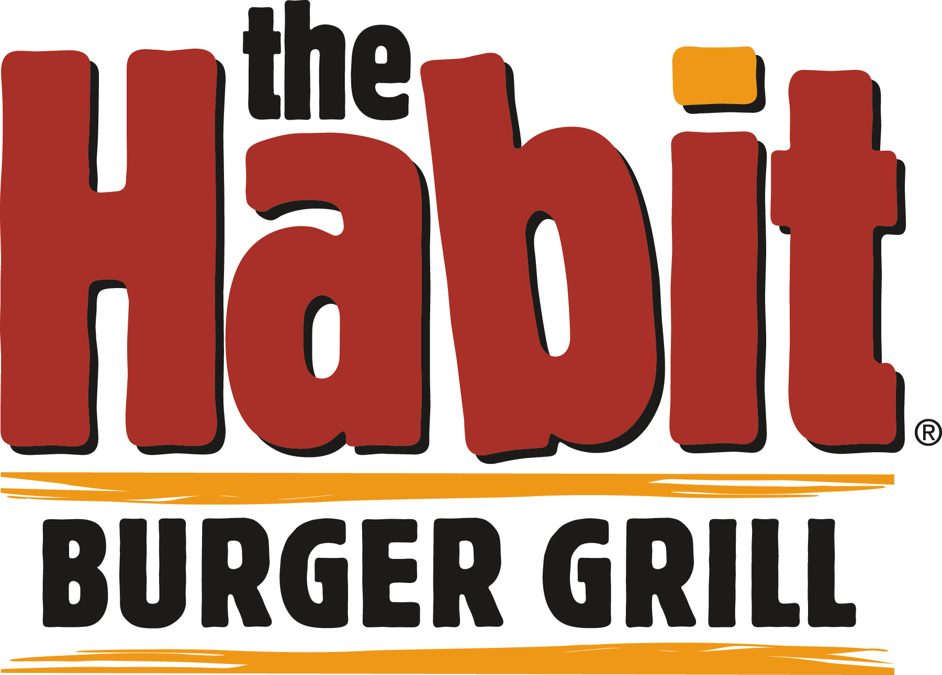

1111 El Camino Real at Sequoia Station
(next to Old Navy)
(650) 568-1625

Wednesday, January 18th
From 4pm to 9pm

Join us and enjoy delicious charburgers, sandwiches, salads and shakes.

Present this flyer when you order and The Habit will donate 20% of the receipts generated to John F Kennedy Middle School PTO!!

JOHN F KENNEDY
MIDDLE SCHOOL
lo invita a éste evento para recaudar fondos a

1111 El Camino Real en Sequoia Station
(Junto a Old Navy)
(650) 568-1625

miercoles 18 de enero
Desde las 4pm hasta las 9pm

Acompañenos a disfrutar de deliciosas hamburguesas, sándwiches, ensaladas y milkshakes!

¡Presente éste volante cuando ordene y The Habit donará 20% de las ventas a John F Kennedy Middle School PTO!

