JOHN F KENNEDY MIDDLE SCHOOL
invites you to attend
our fundraising event at

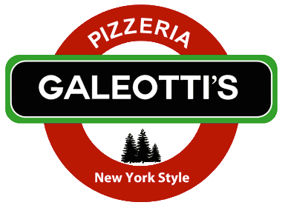
3121 Jefferson Ave. Redwood City, CA
(650) 780-9622
(by the Donut King)

Wednesday, September 28th
4pm to 9pm

Enjoy great food for dinner at Galeotti’s Pizzeria and they will donate 25% of your purchase to Kennedy.

Just bring in this flyer or mention Kennedy Middle School when ordering your food for dine-in or carry-out.

